1. ***We need to create the Eureka Server.***

***Using spring initializer***

***Starter -🡪 Web***

***Starter 🡪Eureka Server***

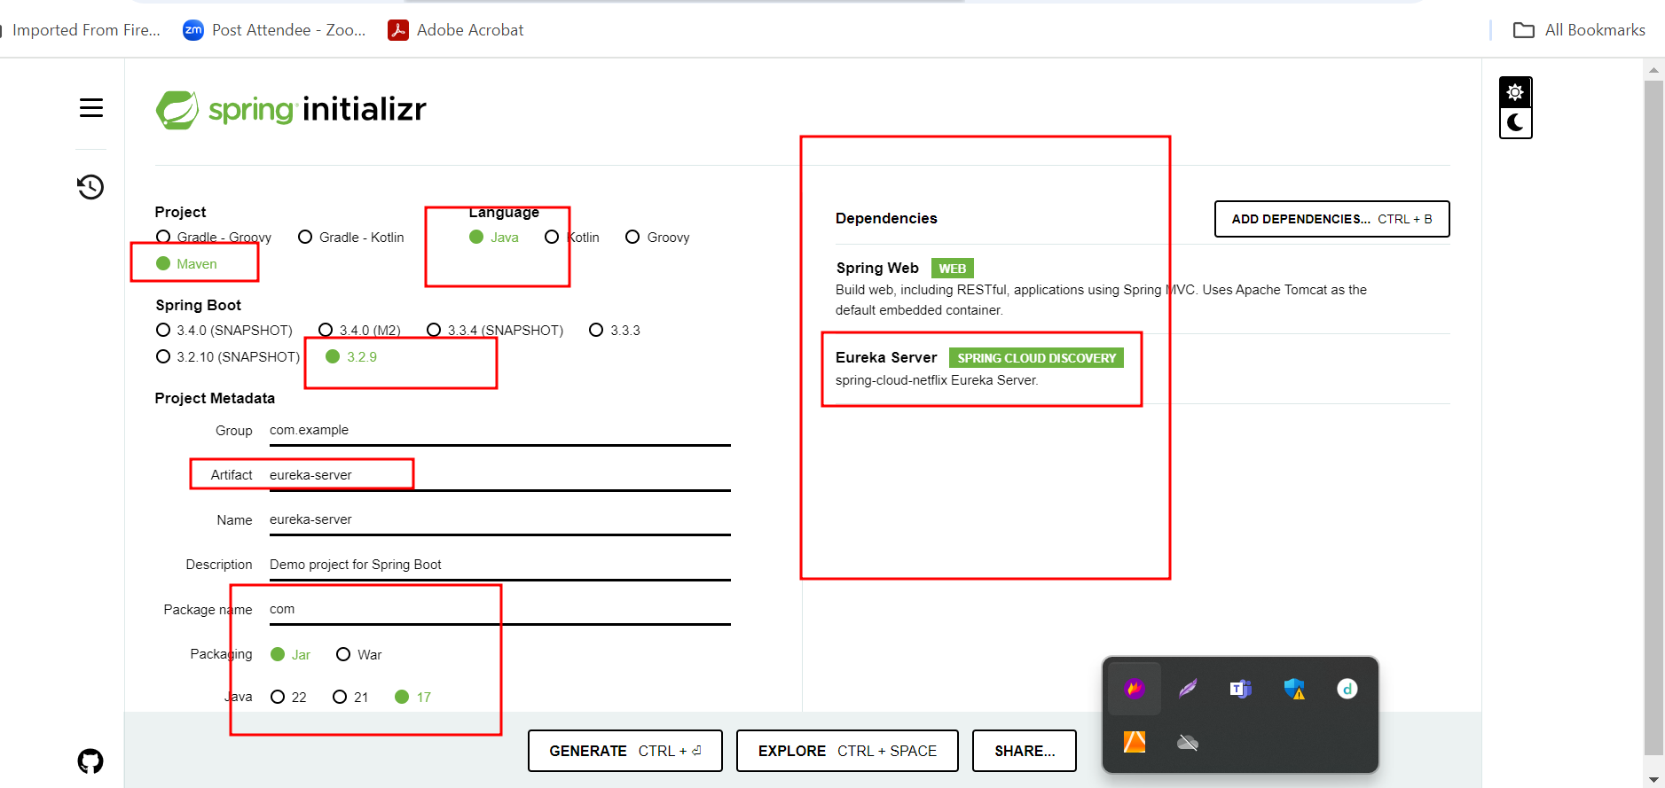

***Whenever we deploy micro service client application by default each micro service project search eureka server on default port number 8761***

***Inside this project in application.properties file add 3 line code***

***spring.application.name=eureka-server***

***server.port=8761***

***eureka.client.register-with-eureka=false***

***eureka.client.fetch-registry=false***

***please use @EnableEurekaServer annotation to enable eureka server.***

***Account-micro-service running with port number 9090***

***With db as mysql db.***

***We create end point***

***To create account***

***Withdraw***

***Deposit***

***findAccountDetails or number***

***findAccountDetails using emailid***

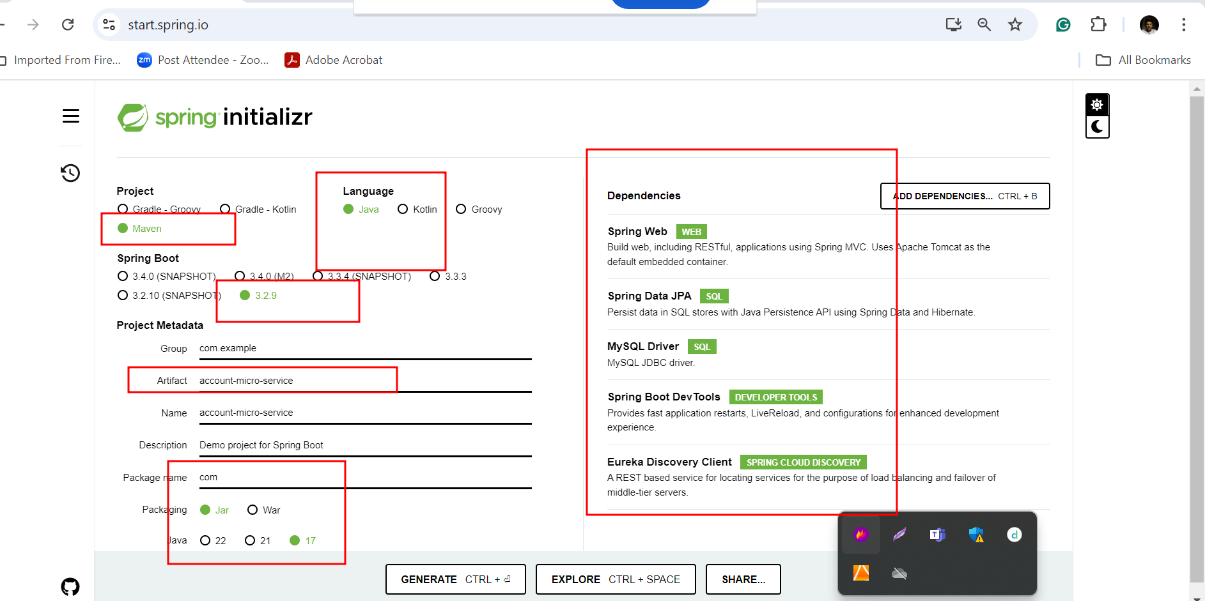

***gpay-micro service running with port number 9191***

***with db as H2 db (H2 is one of the in-memory databases provided by spring boot).***

***Gpay account : we pass emailid using emailid this micro service interact with account micro service to get the account number. If account number present then in gpay micro service we create account with emailid as pk and account number else if account number not present we create account of gpay without link to account.***

***Using gpay id we can check balance withdraw or deposit amount from account micro service.***

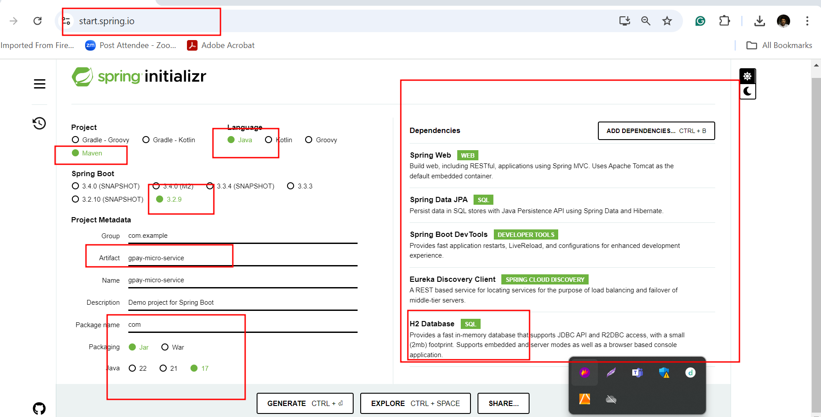

***Gpay micro service what to communicate with account micro service to get some information.***

***Account Micro service become producer to produce the data running on port number 🡪 9090***

***Gpay micro service become consume to consume some data***

***Running on port number 🡪 9191***

***Using***

1. ***RestTemplate : Using RestTemplate we can consume rest api develop in same language or different language.***

***Front end technologies like***

***Angular Using HttpClient we can consume the backend technologies rest api***

***React JS using axios or fetch we can consume the backend technologies rest api.***

***To open H2 database console***

***That application port number ie 9191***

[***http://localhost:9191/h2-console***](http://localhost:9191/h2-console)